

**2. NAHRBTNIK**

**9.PODHLAČE**

**3.DRES**

**2.TORBA**

**8.BUNDA**

**4.NOGOMETNE NOGAVICE**

**7. ANORAK**

**6. KAPA**

**5. TRENERKA ZA TRENING**

**1. HOTELSKA TRENERKA**

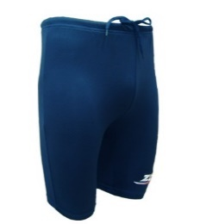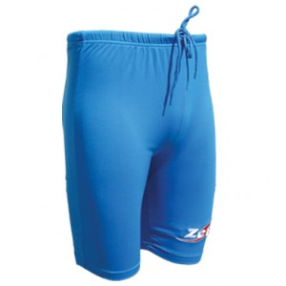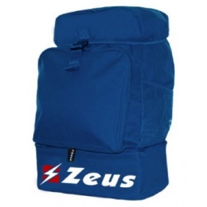

|  |  |  |  |  |  |  |  |  |  |  |  |  |  |  |
| --- | --- | --- | --- | --- | --- | --- | --- | --- | --- | --- | --- | --- | --- | --- |
| POSAMEZNI ARTIKLI | CENA | VELIKOST | | | | | | | | | | | | KOLIČINA |
| 1. HOTELSKA TRENIRKA | 22.00€ | 3XS | 2XS | | XS | | S | | M | | L | XL | 2XL |  |
| 2. TORBA | 18.00€ | / | | | | | | | | | | | |  |
| 2. NAHRBTNIK | 16.00€ | / | | | | | | | | | | | |  |
| 3. DRES | 16.00€ | 3XS | 2XS | | XS | | S | | M | | L | XL | 2XL |  |
| 4. NOGOMETNE NOGAVICE | 2.50€ | KID (28-33) | | JUNIOR (34- 40) | | | | | | SENIOR  (40-47) | | | |  |
| 5. TRENIRKA ZA TRENING | 22.00€ | 3XS | 2XS | | XS | | S | | M | | L | XL | 2XL |  |
| 6. KAPA | 3.50€ | / | | | | | | | | | | | |  |
| 7. ANORAK | 12.00€ | 3XS | 2XS | | XS | | S | | M | | L | XL | 2XL |  |
| 8. BUNDA | 26.00€ | / | 2XS | | XS | | S | | M | | L | XL | 2XL |  |
| 9. PODHLAČE | 7.00€ | M | | L | | XL | | SVETLO MODRE | | | | | |  |
| TEMNO MODRE | | | | | |
| SKUPAJ: |  | | | | | | | | | | | | | |

|  |  |  |  |  |  |  |  |  |  |  |  |  |  |  |  |  |  |
| --- | --- | --- | --- | --- | --- | --- | --- | --- | --- | --- | --- | --- | --- | --- | --- | --- | --- |
| VELIKI PAKET | | VELIKOST | | | | | | | | | | | | | | | |
| 1. HOTELSKA TRENERKA | | 3XS | | 2XS | | XS | | | S | | M | | L | XL | | 2XL | |
| 2. | TORBA | OBKROŽI, TORBO **ALI** NAHRBTNIK. | | | | | | | | | | | | | | | |
| NAHRBTNIK |
| 3. DRES | | 3XS | 2XS | | XS | | | S | | M | | L | | | XL | | 2XL |
| 4. NOGOMETNE NOGAVICE | | KID  (28-33) | | | | | JUNIOR (34- 40) | | | | | | SENIOR  (40-47) | | | | |
| 5. TRENERKA ZA TRENING | | 3XS | | 2XS | | XS | | | S | | M | | L | XL | | 2XL | |
| 6. KAPA | | UNIVERZALNO | | | | | | | | | | | | | | | |
| 7. ANORAK | | 3XS | | 2XS | | XS | | | S | | M | | L | XL | | 2XL | |
| 8. BUNDA | | 2XS | | | | XS | | | S | | M | | L | XL | | 2XL | |
| CENA 110,00€ | | | | | | | | | | | | | | | | | |

|  |  |  |  |  |  |  |  |  |  |  |  |  |  |  |  |  |
| --- | --- | --- | --- | --- | --- | --- | --- | --- | --- | --- | --- | --- | --- | --- | --- | --- |
| SREDNJI PAKET | | VELIKOST | | | | | | | | | | | | | | |
| 1. HOTELSKA TRENERKA | | 3XS | | 2XS | | XS | | | S | | M | | L | XL | 2XL | |
| 2. | TORBA | OBKROŽI, TORBO **ALI** NAHRBTNIK. | | | | | | | | | | | | | | |
| NAHRBTNIK |
| 3. DRES | | 3XS | 2XS | | XS | | | S | | M | | L | | XL | | 2XL |
| 4. NOGOMETNE NOGAVICE | | KID  (28-33) | | | | | JUNIOR (34- 40) | | | | | | SENIOR  (40-47) | | | |
| 5. TRENERKA ZA TRENING | | 3XS | | 2XS | | XS | | | S | | M | | L | XL | 2XL | |
| CENA 75,00€ | | | | | | | | | | | | | | | | |

|  |  |  |  |  |  |  |  |  |  |  |  |  |  |  |  |
| --- | --- | --- | --- | --- | --- | --- | --- | --- | --- | --- | --- | --- | --- | --- | --- |
| MALI PAKET | | VELIKOST | | | | | | | | | | | | | |
| 1. HOTELSKA TRENERKA | | 3XS | | 2XS | | XS | | | S | | M | L | XL | 2XL | |
| 2. | TORBA | OBKROŽI, TORBO **ALI** NAHRBTNIK. | | | | | | | | | | | | | |
| NAHRBTNIK |
| 3. DRES | | 3XS | 2XS | | XS | | | S | | M | | L | XL | | 2XL |
| 4. NOGOMETNE NOGAVICE | | KID (28-33) | | | | | JUNIOR (34- 40) | | | | | | SENIOR (40-47) | | |
| CENA 55,00€ | | | | | | | | | | | | | | | |

IME in PRIIMEK:_______________________________________________

CENA SKUPAJ:________________________________________________

VPLAČAL PODPIS : ______________________________

PREJEL PODPIS: _____________________________________

**PRVI DEL ODREZKA OBDRŽI KLUB**

**DRUGI DEL ODREZKA OBDRŽI PLAČNIK**

IME in PRIIMEK:_______________________________________________

CENA SKUPAJ:________________________________________________

VPLAČAL PODPIS : ______________________________

PREJEL PODPIS: _____________________________________